Pike Creek Valley Running Club’s
Couch to 5K – Fall 2016 Info
Who: Everyone! All fitness levels are welcome. Whether you are a runner, jogger, run-walker or walker, we have a Couch to 5K program for you!
What: PCVRC’s Fall 2016 Couch to 5K - Ten Week Training Session
When: Mondays 6pm Aug 1 to Oct 2
Where: The Newark Reservoir on Old Paper Mill Rd (a beautiful setting!!)
Why: Because C25K is a fun, social way to get healthy and into better shape. Allow our team of experienced runners and walkers help you get off the couch and reach your goal of running or walking a 5K !
Cost: FREE! (PCVRC is a 501c3)
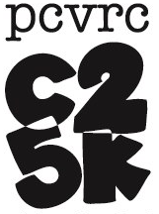
Website: http://pcvrc.com/
For further info on Couch to 5K or the Pike Creek Valley Running Club:
Amy Temple: amy.l.temple@siemens.com
Christina Xia: christina.xia@siemens.com Joel Schiller: jschiller@artisansbank.com
Our Celebratory Goal 5K will be Delaware Distance Classic 15K/5K in Delaware City on 10/9/16. This is a PCVRC hosted event!

